VUSAL NASIRLI

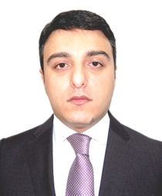
PERSONAL DATA
DoB 3 March 1978
Languages English, Russian, Turkish
Marital status Married (2 children)
Citizenship Azerbaijan

EXPERIENCE
Azerbaijan Boxing Federation, 2022-Present
- Vice-President

Ministry of Labour and Sosial Protection of Population, 2018-Present
- Deputy Minister

Ministry of Labour and Sosial Protection of Population, 2018-2018
- Advisor to the Minister

Ministry of Economy, 2013-2018
- Deputy Head of Department for Cooperation with International Organizations

Ministry of Economic Development, Integrated Solid Waste Management Project, 2009-2013
- Deputy Head of Project Implementation Unit

Pegasus Forwarding Company, 2007-2009
- Business Development Manager

Atasigorta Insurance Company, 2004-2007
- Manager; Director of Marketing Department; Director of Sales and Marketing Department

Azpetrol Oil Company, 2004-2004
- Budget Control Manager

Qafqaz Insurance Company (Azpetrol captive insurance company), 2003-2004
- Business Development Manager

Belmont Global (Consulting company), 2001-2003
- Advisor

EDUCATION

Azerbaijan State University of Economics, 2019
- Faculty of Organization and Management of Industry

Qafqaz University, Public Administration Faculty
- Master of Public and Municipal Administration, 2002

UK Royal Chartered Insurance Institute (CII), 2005-2006
- Insurance

